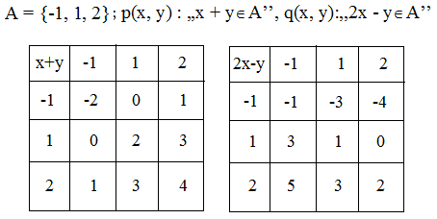

|  |  |  |  |
| --- | --- | --- | --- |
| ,,  p(x, y) A’’ |  | ,,  q(x, y) A’’ |  |
| ,,  p(x, y) A’’ |  | ,,  q(x, y) A’’ |  |
| ,,  p(x, y) A’’ |  | ,,  q(x, y) A’’ |  |
| ,, p(x, y) A’’ |  | ,,  q(x, y) A’’ |  |

Prof. Cosma Teodora