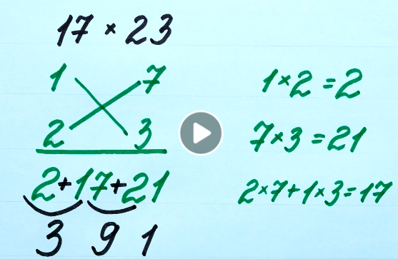
Adresa unde pot fi vizualizate este:
https://www.facebook.com/ideasen5minutos/videos/2104710756410525
professor, Teodora Cosma

