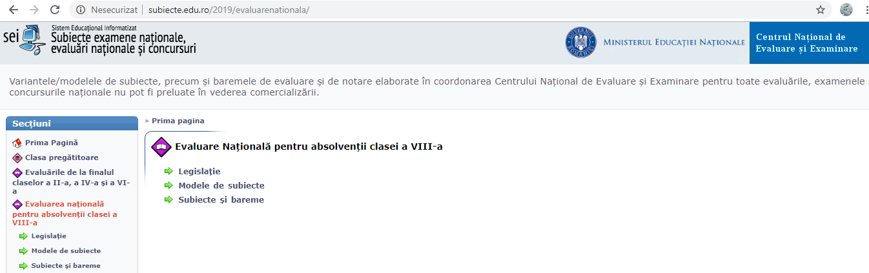
http://subiecte.edu.ro/2019/evaluarenationala
Succes !
Prof. Cosma Teodora

