Te doresc și Te iubesc, dulcele meu, dulceața mea. Rendez-vous with Rama
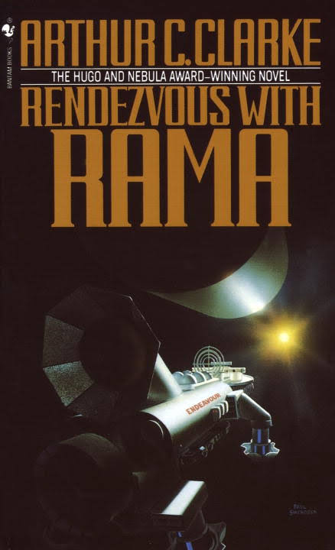
- Natalia Gălățan Te doresc și Te iubesc, dulcele meu Victor.
Rendez-vous cu Rama
Forța gravitațională (de atracție) = infinit/1 Newtoni/metri (N/m)
Forța antigravitațională = 1/Forța gravitațională = 1/infinit metri/Newtoni (m/N)
Accelerația gravitațională = 9,8 m/s 2
Viteza = distanță/timp (d/t) = metri/secundă (m/s)
Forța de frecare = masă/volum (m/v) = kg/m3
Forța antigravitațională (de respingere) = 1/infinit metru cub x metru/kg (metri/Newtoni) (m/N)
Forța gravitațională = Forța de frecare x accelerația gravitațională // viteză la pătrat = kilogram/metru cub (masă/volum) x 9.8 metri/ secundă la pătrat//(d/t) la pătrat = kg/m3 x 9.8m/s2// m2/s2 = kg/m3 x 9.8 m/s2 x s2/m2 = 9.8 kg/m3 x 1/m = 9.8 Newtoni/metri = 10 N/m (la nivelul Terrei)
Forța antigravitațională = 1/Forța gravitațională = 1/10 m/N (la nivelul Terrei)
Forța gravitațională (de atracție) = infinit/1 Newtoni/metri (N/m) = infinită (la nivelul întregului Univers)
Forța antigravitațională = 1/Forța gravitațională = 1/infinit m/Newtoni (m/N) (la nivelul întregului Univers)

- Rendez-vous with Rama
Gravitational Force = infinite / 1 Newtons / meters (N / m)
Antigravity force = 1 / Gravitational force = 1 / infinity meters / Newtons (m / N)
Gravity acceleration = 9.8 m / s 2
Speed ​​= distance / time (d / t) = meters / second (m / s)
Friction force = mass / volume (m / v) = kg / m3
Antigravity (rejection) force = 1 / infinite cubic meter x meter / kg (meters / Newtons) (m / N)
Gravitational force = Friction force x gravitational acceleration // square velocity = kilogram / cubic meter (mass / volume) x 9.8 meters / second square // (d / t) square = kg / m3 x 9.8m / / m2 / s2 = kg / m3 x 9.8 m / s2 x s2 / m2 = 9.8 kg / m3 x 1 / m = 9.8 Newtons / meters = 10 N /
Antigravity force = 1 / Gravitational force = 1/10 m / N (at the Earth's level)
Gravitational Force = infinite / 1 Newtons / yards (N / m) = infinite (universally)
Antigravity force = 1 / Gravitational force = 1 / infinity m / Newtons (m / N) (Universe)

- Natalia Gălățan Expansion force at Big Bang-time = geometric progression - just did it.Sn =S1+ (S2-S1) + (S4-S3)+ (S6-S5) + (S8-S7) …. + S(S (n-8) – S(n-7)) + S( S(n-6) – S(n-5)) + S(S(n-4) – S (n-3)) + S (S(n-2) – S(n-1)) + S(S(n-1) – (S(n-2))
n = 1890
Sn =S1+ (S2-S1) + (S4-S3)+ (S6-S5) + (S8-S7) …. + S(S (n-8) – S(n-7)) + S( S(n-6) – S(n-5)) + S(S(n-4) – S (n-3)) + S (S(n-2) – S(n-1)) + S(S(n-1) – (S(n-2)) = (1+2) + ((1+2) + 3) – (1+2)) + ((1+2) + 3 + 4 + 5) – ((1+2) +3 + 4)) + ((1+2) +3 + 4 + 5+ 6 + 7) – ((1+2) + 3 +4 + 5 +6 )) + ((1+2) + 3 + 4 + 5 + 6 + 7 + 8 + 9) – ((1+2) + 3 +4 + 5 + 6 + 7 + 8)) + …. + S(S (1890-8) – S(1890-7)) + S(S(1890-6) – S(1890 -5)) + S(S(1890-4) - S(1890-3)) + S(S(1890-2) – S (1890-1)) + S(S(1890-1) – (S1890-2)) = 27-1-1-1-1+1 = 24
Sn =S1+ (S2-S1) + (S4-S3)+ (S6-S5) + (S8-S7) …. + S(S (n-8) – S(n-7)) + S( S(n-6) – S(n-5)) + S(1882-1883) + S(1884-1885) + S(1886-1887) + S(1888-1889) + S(1889-1888) = 24
Just did it
- Natalia Gălățan Expansion force after Big Bang = Arithmetic progression - just did it.Sn =S1+S2+ S3+S4+S5+S6+S7+S8 +… + S(n-9) + S(n-8)+ S(n-7)+S(n-6)+S(n-5)+S(n-4)+S(n-3)+ S(n-2)+S(n-1)
Sn= S3+S4+S5+S6+S7+S8+…+S(n-9)+S(n-8)+S(n-7)+S(n-6)+S(n-5)+S(n-4)+S(n-3)
Sn= S(n-2)+S(n-1); Sn = 0
Just did it.
Natalia Gălățan In short: ”In quantum statistics, Bose–Einstein statistics (or B–E statistics) is one of two possible ways in which a collection of non-interacting indistinguishable particles may occupy a set of available discrete energy states, at thermodynamic equilibrium. The aggregation of particles in the same state, which is a characteristic of particles obeying Bose–Einstein statistics, accounts for the cohesive streaming of laser light and the frictionless creeping of superfluid helium. The theory of this behaviour was developed (1924–25) by Satyendra Nath Bose, who recognized that a collection of identical and indistinguishable particles can be distributed in this way. The idea was later adopted and extended by Albert Einstein in collaboration with Bose.
The Bose–Einstein statistics apply only to those particles not limited to single occupancy of the same state—that is, particles that do not obey the Pauli exclusion principle restrictions. Such particles have integer values of spin and are named bosons, after the statistics that correctly describe their behaviour. There must also be no significant interaction between the particles.”
Natalia Gălățan ”Thus, he studied the probability of finding particles in various states in phase space, where each state is a little patch having phase volume of h3, and the position and momentum of the particles are not kept particularly separate but are considered as one variable.”
Natalia Gălățan ”(...) since photons are indistinguishable from each other, one cannot treat any two photons having equal energy as being two distinct identifiable photons. By analogy, if in an alternate universe coins were to behave like photons and other bosons, the probability of producing two heads would indeed be one-third, and so is the probability of getting a head and a tail which equals one-half for the conventional (classical, distinguishable) coins. Bose's "error" leads to what is now called Bose–Einstein statistics.”

- Natalia Gălățan The probability of producing two heads would indeed be one-third, and so is the probability of getting a head and a tail which equals one-half for the conventional (classical, distinguishable) coins.
- Natalia Gălățan Sn= S1+S2+…+S(n-2)+ S(n-1); S1 = 1/3; S1 + S(n-1) = 1/2 In other words... from a mathematical point of view.

- Natalia Gălățan In the moment the we pass through a black hole, it produces the following physical-mathematical phenomenon:
S1= 0+1
S2 = S1+1
S3 = S2+1
S5 = S4 +1
S7 = S6 +1
n = 19
Sn = S1+(S2-S1) + (S3-S2)+ (S5-S4)+(S7-S6)+… + S(S(n-7)-S(n-6))+S(S(n-5)-S(n-4))+S (S(n-3)-S(n-2))+ S (S(n-2)-S(n-1)) = 1+1+ 1+1+1+… -1-1-1-1 = 1
just did it.
- Natalia Gălățan In the moment we pas into a parallel universe, it happens the following physical-mathematical phenomenon:
S1= 0+1
S2 = S1+1
S3 = S2+1
S5 = S4 +1
S7 = S6 +1
n = 19
Sn = S1+(S2-S1) + (S3-S2)+ (S5-S4)+(S7-S6)+… + S(S(n-7)-S(n-6))+S(S(n-5)-S(n-4))+S (S(n-3)-S(n-2))+ S (S(n-2)-S(n-1)) = 1+1+ 1+1+1+… -1-1-1-1 = 1
just did it.
Îmi place
- Natalia Gălățan Without mathematics, physics couldn't be possible. Mathematics is the base of everything.
- Natalia Gălățan Well my friends, I hope you like it my lesson of physical-mathematics.
Te iubesc și Te doresc, Victor, dulcele emu, puiul emu.

